# Justification for Game Theme

## Designing from Emotion

Given the basis that all good game design starts by considering the emotional responses a designer wants to trigger from their audience, it is important to first highlight these said emotions.

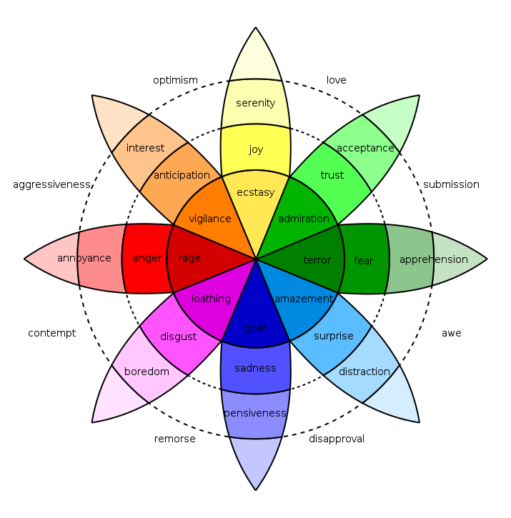

Figure - Robert Plutchik's wheel of emotions

In relation to Plutchik’s wheel of emotion illustrated above, the desired emotions we wish to trigger within our game are primarily vigilance and ecstasy – we need to keep our players in a state of flow and for them to be enjoying our game while doing so.

These emotions are primarily delivered through the games’ core mechanics (as alluded to in the slides on flow theory and 4 keys 2 fun from our initial pitch).

Consequently, and as alluded to by our first wave of feedback, we can ‘skin’ the game thematically more or less however we like. Because of this, we eventually decided upon a theme of fighting ducks.

## Why Fighting Ducks?

There were a few key reasons we chose this theme, as follows:

1. Natural and intuitive controls
   1. As our game has a very simple one tap mechanic, the telegraphing and feedback from the game needs to feel as natural and instinctive as possible. Our game is themed on ducks, ducks swim on water, every single human being alive today understands water. They know how it feels, they know how it sounds and they understand how it interacts with other objects. If utilised correctly, we can use this to our advantage and make the game feel as natural as possible.
2. A light-hearted and comedic twist
   1. As a local multiplayer mobile game, our game is likely to be played in short bursts when players have a few minutes of downtime with a friend (on a lunchbreak, for example). A deep, detailed narrative is inappropriate for this game for multiple reasons, most important of which being the game is a social experience. Diluting the focus from this with complex characters and an engaging narrative would only distract players from the main point of our game – having fun with friends.
   2. Given the above, our game instead requires a self-aware, comedic twist. Akin to the “Exploding Kittens” card game, a humorous, ridiculous approach thematically not only allows players to engage competitively within the core game loop but also further deepens the social experience by allowing players to laugh together at the game itself (games such as Goat Simulator do an excellent job at this).
3. Smashing through first-level consciousness
   1. The theme of “fighting ducks with arms” opens the doors to a practically infinite amount of crazy combinations
   2. Using random generation, for example, these combinations can become truly unique and creative. Nobody likes the boring and predictable.